Bats on Halloween Night
By Helen Castaneda
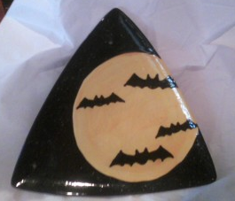

Project Piece Brushes
Medium Geometric Plate #4 or 6 Round 2153 #1 Liner
#4 or #6 Shader
Concepts Fan Glaze
CN032 Bright Butternut
CN501 Neon Yellow Envision Glaze
CN253 Black IN1216 Very Black Sprinkles
French Dimensions Glaze
FD258 Pure White Pure Brilliance
FD277 Neon Coral

Miscellaneous

Pencil
Water Bowl Sponge
Palette Paper or Glazed Tile Contact Paper for Moon & Bats

- Wipe down medium Geometric Plate lightly using a damp sponge to remove dust from back and front side.
- Place contact paper of the moon where you would like the moon placed on your plate.
- Using the fan glaze, brush on 3 coats of IN1216 Very Black Sprinkles with drying time between coats. Before the 3rd coat is dry remove contact paper.
- When 3rd coat of glaze is dry place the contact paper bats where you would like them placed in the moon
- Using a fan glaze or #6Round apply 2 coat of CN501 Neon Yellow to moon area dry in between coats. Apply the 3rd coat with CN032 Bright Butternut. Before the 3rd coat is dry remove the bat contact paper.
- Using #4 or #6 Round apply 3 coats of CN253 Black to the area that the bats were placed.
- When bats our dry place a small amount of FD277 Neon Coral for the bat eyes and FD258 for the fangs.
- Sign your piece and let dry.
- Apply Pure Brilliance Glaze to moon area only, when dry fire to shelf cone 06.

